2026
Harpreet Singh
011932084
1/30/2026
Supervised Learning – Conceptual Assignment Report
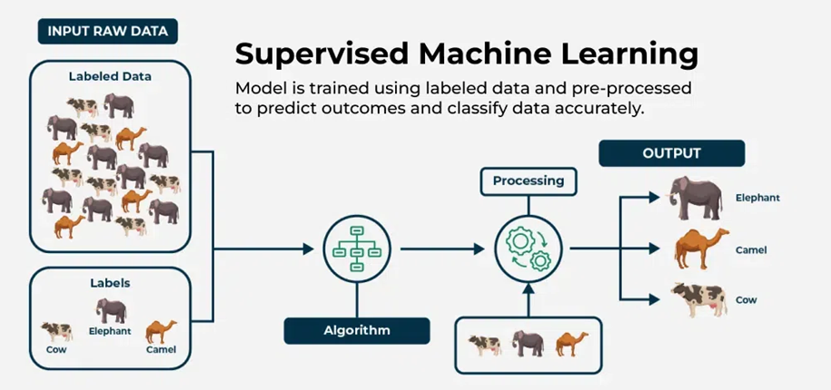

Assignment: Supervised Learning
A conceptual assignment report
Course: Artificial Intelligence
Submission by Harpreet Singh
011932084
1/30/2026

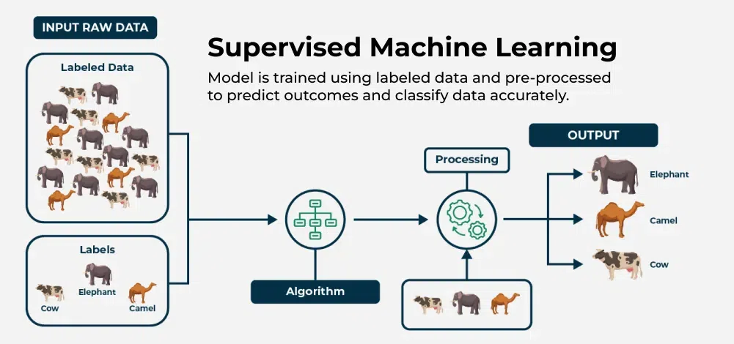

Supervised Learning – Conceptual Assignment Report

Question 1: Fundamentals of Supervised Learning

a) Definition and Difference from Unsupervised Learning
Supervised learning is a branch of machine learning in which a model is trained using labeled data. Each training example includes both input features and the correct output. The model learns a mapping from inputs to outputs, allowing it to make predictions on new, unseen data.
In contrast, unsupervised learning works with unlabeled data. The goal is not to predict a known output but to discover hidden patterns, structures, or groupings within the data.
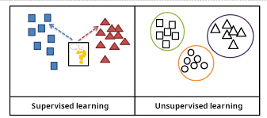
Facet | Sup. Learning | Unsup. Learning
Data | Labeled | Unlabeled
Goal | Predict outcomes | Discover patterns
Example | Predicting house prices | Customer segmentation

b) Two Main Components Required
- Input Features (X)
These are the measurable attributes or characteristics used to make predictions. For example, in house price prediction, features may include size, location, and number of bedrooms.
- Target Labels (y)
These are the correct outputs associated with each input. They represent what the model is trying to learn to predict (e.g., actual house price).
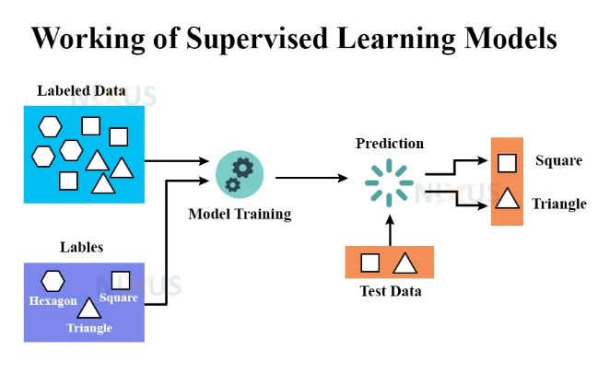

c) Role of Labels and Why Quality Matters
Labels act as the ground truth that guides the learning process. During training, the model compares its predictions to the true labels and adjusts itself to reduce errors.
Poor-quality labels (incorrect, inconsistent, or biased) can mislead the model, causing it to learn the wrong patterns. This results in inaccurate predictions and poor real-world performance.

Question 2: Types of Supervised Learning Problems
- Classification vs Regression

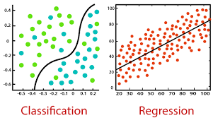
Characteristic | Classification | Regression
Output Type | Categories or classes | Continuous numeric value
Example | Spam vs Not Spam | Predicting temperature
Goal | Assign to a class | Estimate a quantity

b) Problem Identification
Scenario | Type | Justification
Email spam detection | Classification | Output is a category (spam/not spam)
Selling price of a used car | Regression | Output is a numeric value
Fraudulent transaction detection | Classification | Output is a class (fraud/not fraud)
Number of customers next week | Regression | Output is a count (numeric prediction)

c) Why Some Problems Are Hard to Categorize
Some real-world problems involve both types. For example, predicting whether a patient has a disease (classification) and estimating its severity (regression). Also, continuous values are sometimes converted into categories (e.g., income → low/medium/high), which blurs the distinction.

Question 3: Data and Features

a) What Are Features?
Features are the input variables that describe each data point. They provide the information the model uses to make predictions.
Example (Student Performance):
Study Hours | Attendance | Previous GPA | Final Grade (Label)

b) Importance of Feature Selection
Relevant features improve prediction accuracy. Irrelevant or redundant features can:
- Confuse the model
- Increase training time
- Lead to overfitting
Good feature selection helps the model focus only on meaningful information.

c) Common Data Quality Issues
- Missing Values – Incomplete data can distort learning
- Noisy Data – Errors or random variations reduce accuracy
- Imbalanced Data – One class heavily outnumbers others, biasing predictions

Question 4: Model Training and Generalization

a) Concept of Model Training
Training is the process by which the model learns patterns by comparing predictions with true labels and adjusting its internal parameters to minimize errors.

b) Overfitting vs Underfitting
Concept | Description | Effect
Overfitting | Model memorizes the training data too closely | Poor performance on new data
Underfitting | Model is too simple to capture patterns | Poor performance on both training and new data

c) Importance of Train–Test Split
Data is split into:
- Training set – Used to teach the model
- Testing set – Used to evaluate performance on unseen data
This helps measure how well the model generalizes beyond the training examples.

Question 5: Model Evaluation

a) Why Evaluation Is Necessary
Evaluation determines whether the model makes reliable predictions and whether it is suitable for real-world use.

b) Accuracy vs Error
- Accuracy: Proportion of correct predictions
- Error: Proportion of incorrect predictions
They are complementary (Accuracy = 1 − Error).

c) Why Accuracy Alone Is Not Enough
In medical diagnosis or fraud detection, one class is rare but very important. A model can have high accuracy by always predicting the majority class, yet fail to detect critical cases. Metrics like precision and recall are often more informative in such cases.

Question 6: Assumptions and Limitations

a) Common Assumptions
- Training and future data follow similar patterns
- Features contain enough information to predict the label

b) Limitations
- Dependence on labeled data – Labeling can be expensive and time-consuming
- Limited to known outcomes – Cannot discover completely new patterns like unsupervised learning

Question 7: Supervised Learning in Research – Random Forests

a) Problem Statement
Single decision trees often suffer from high variance — small changes in data can lead to very different trees. They can also overfit training data.
Improving accuracy and robustness was important to create models that perform consistently on new data.

b) Use of Supervised Learning
Random Forests use labeled data to learn the relationship between input features and output labels.
- Features describe each data point
- Labels represent the correct outcome
- The method works for classification (majority vote) and regression (average prediction)

c) Model Training and Evaluation (Conceptual)
Multiple decision trees are trained using different random samples of the dataset and different subsets of features. Each tree makes its own prediction.
The final prediction is made by combining all tree outputs:
- Majority vote (classification)
- Average value (regression)
Performance is evaluated by checking how well these combined predictions match the true labels on unseen data.

d) Impact and Limitation
Impact:
Random Forests became widely used in healthcare, finance, and marketing because they provide strong performance, handle large datasets, and reduce overfitting compared to single trees.
Limitation:
They are less interpretable than a single decision tree. It is harder to explain how individual predictions are made.

